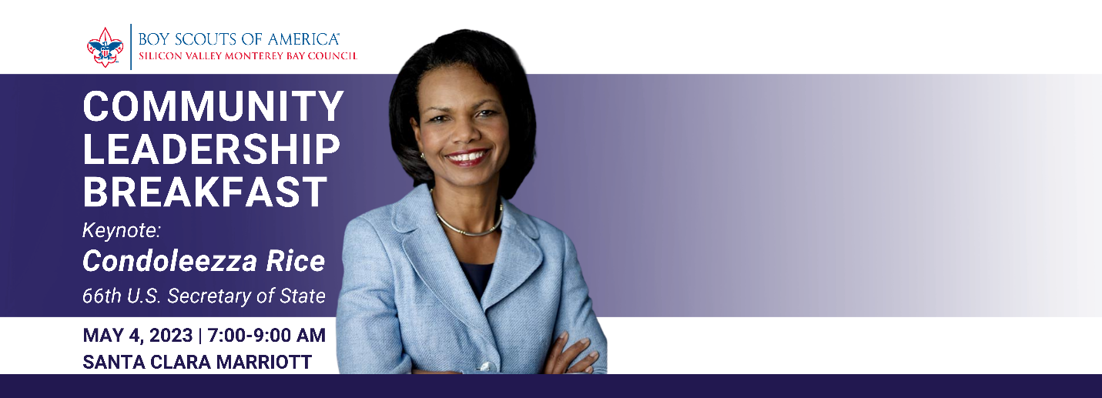

Dear [First],

We have an opportunity to share that you may find of particular interest. Of the many requests you and I receive daily, this is well worth it. On May 4th, Condoleezza Rice, 66th U.S. Secretary of State and Director of the Hoover Institution, will join us as keynote speaker at the Community Breakfast for Scouting at the California Ballroom at the Santa Clara Marriott Hotel. The opportunity to meet a leader of this caliber is rare, and I’m writing to ask for your help.

Secretary Rice is not only a former head of state, but a respected institution leader, accomplished athlete and multiple book author. We want to fill the room. Our local Scout Council, serving families from Milpitas to King City is a leader in the Western Scouting region. We want to show Secretary Rice the pride and success that innovative business and community leadership brings to our valley and the world. To achieve this, please consider joining me to hear her message and donate to Scouting.

While this is a no cost to register event, you will be asked to consider supporting our local scouting program with a minimum contribution of $350, which will support one Scout for one year in the program. If you would like to support more than one Scout, that is even better! Supporters who make a gift of $2500 or more are eligible for special incentives available only at the breakfast event. If you are unable to make the event, please know that you can still make a gift to Scouting to show your support by visiting the registration link below. Please reach out to me or Chief Development Officer, Heather Lerner at heather.lerner@scouting.org with any questions. Please RSVP at your earliest convenience via our quick link, https://p2p.onecause.com/bsabreakfast2023. Thank you for your leadership of our community and your support of Scouting!

Thank you.

(ENTER YOUR NAME)

