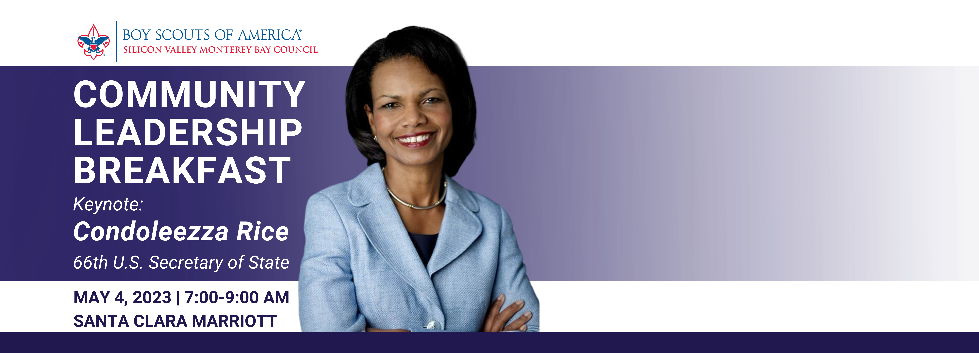

Dear NAME,

I am really excited to invite you to a breakfast supporting the Boy Scouts at Santa Clara Marriott Hotel’s California Ballroom featuring keynote speaker Condoleezza Rice, 66th Secretary of State and Director of the Hoover Institution. This is the Annual Community Leadership Breakfast benefiting the Silicon Valley Monterey Bay Council, Boy Scouts of America. The breakfast is a key part of our annual fund-raising and development plan. I hope you will join me at this event.

There is NO COST to attend this breakfast. However, you will be asked during the breakfast to make a minimum tax-deductible contribution of $350 to the Boy Scouts. This is the cost to underwrite each one of our 9,000 youth annually.

You can RSVP online or email me. Please be sure to indicate that you are attending as one of my guests, so you can be seated at my table. I am also happy to mail you a formal invitation.

If you cannot attend and wish to donate, visit the RSVP website to make a gift or let me know and I will have a BSA staff member follow up with you.

I hope you will join me at this great event, be inspired by Secretary Rice and, after more than 100 years of delivering Scouting locally, know the future is bright with Scouts as tomorrow’s role models and engaged citizens. If you have any questions about the event, contact me at PHONE NUMBER or EMAIL.

Date: May 4th, 2023
Time: 7:00 AM to 9:00 AM
Location: Santa Clara Marriott Hotel
Parking: On site

Thank you.
(ENTER YOUR NAME)

